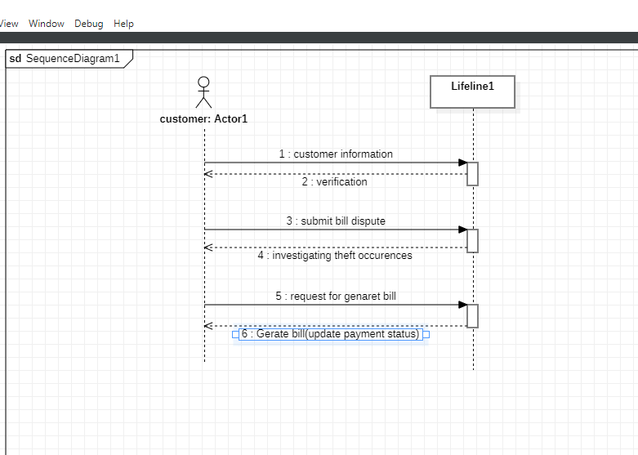**MAIN SUCCESS SCENARIO:**

Customer will login .

Customer will request for metre-bill.

Investigation confirms the occurrence of electricity theft,Sytem calculates the amout of electricity stolen.

Billing system will generate Bill(payment through cards).

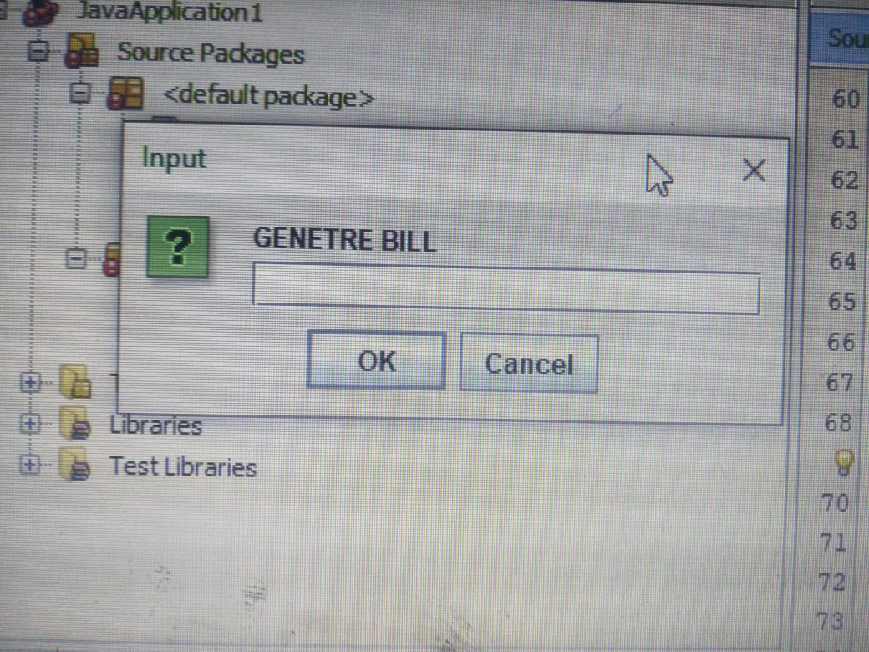

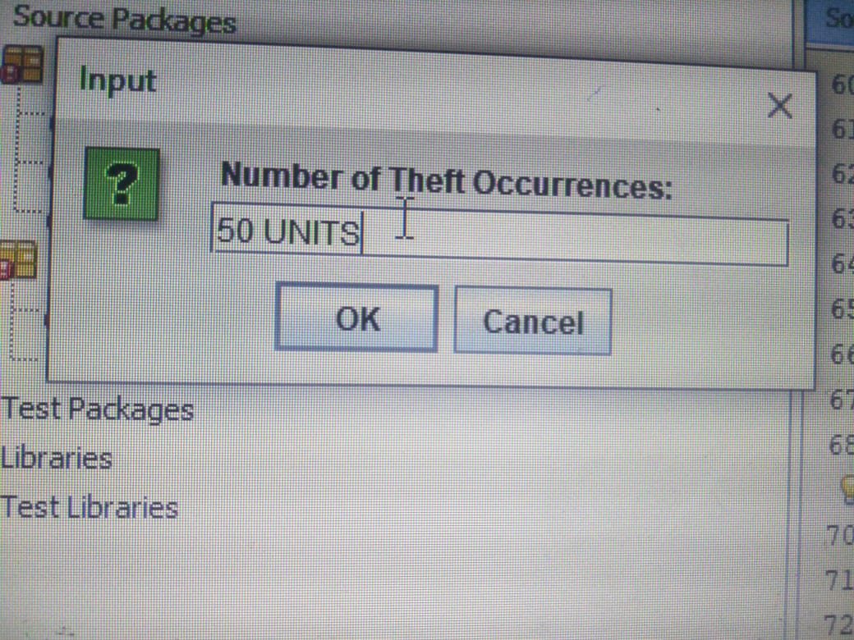

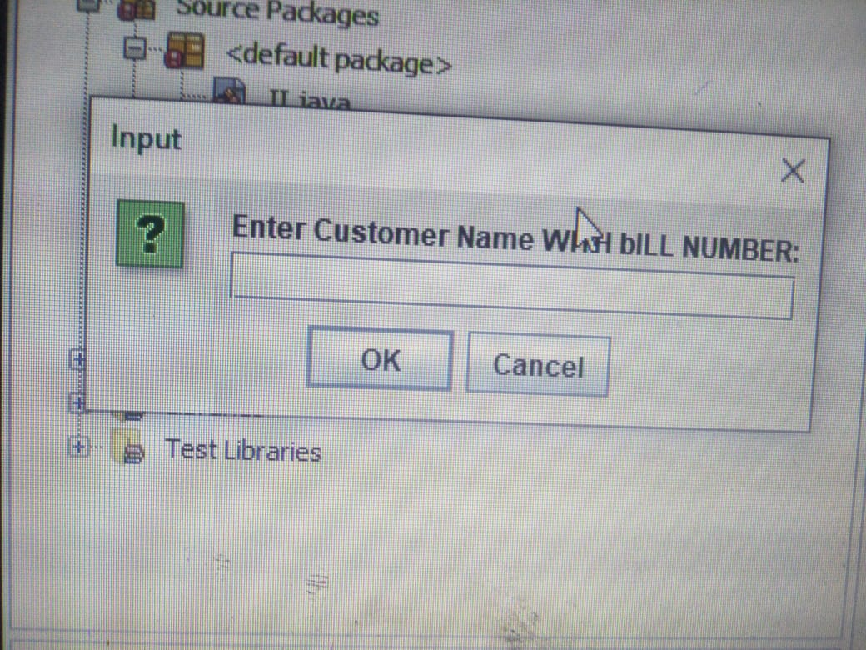

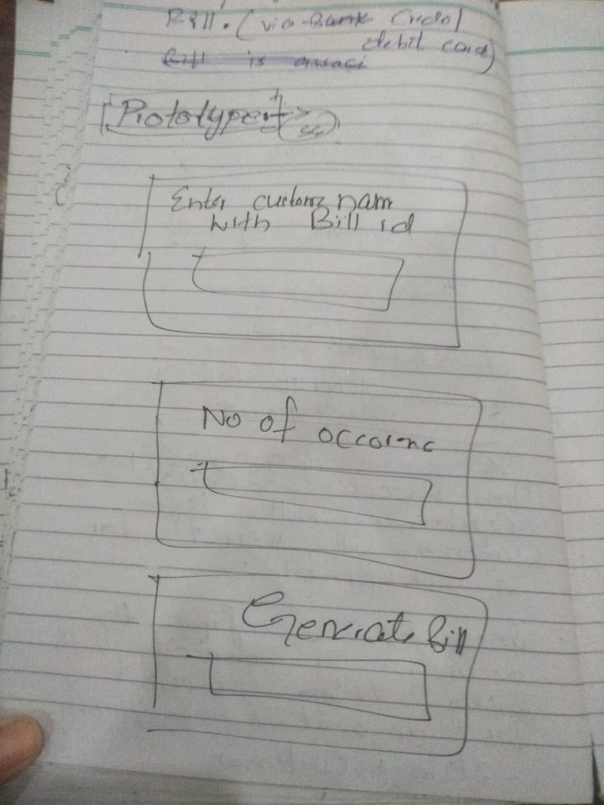

Ss 2

Dfdg

